Final Report: Smart Sorting: Transfer Learning for Identifying Rotten Fruits and Vegetables

# 1. INTRODUCTION

## 1.1 Project Overview

**Smart Sorting: Transfer Learning for Identifying Rotten Fruits and Vegetables** aims to develop an intelligent system that uses transfer learning to automatically detect and classify rotten fruits and vegetables. By leveraging pre-trained deep learning models, the project enhances accuracy and reduces the need for large training datasets. This system helps automate the sorting process, improves quality control, and minimizes food waste in agricultural and retail sectors.

## 1.2 Purpose

To automate the detection of spoiled produce using deep learning techniques. This reduces reliance on manual inspection, enhances the efficiency and accuracy of sorting processes, and helps minimize food waste by ensuring only fresh fruits and vegetables reach consumers.

# 2. IDEATION PHASE

## 2.1 Problem Statement

Manual sorting of fruits and vegetables to identify rotten items is labor-intensive, time-consuming, and often inaccurate, leading to inefficiencies and increased food waste. Traditional machine learning models require large, labeled datasets and extensive training time, which limits their practicality. There is a need for a smart, efficient, and accurate solution that can automate the detection of rotten produce using limited data and computational resources.

## 2.2 Empathy Map Canvas

**Project Focus:** The project focuses on developing an automated image-based classification system that uses transfer learning to identify rotten fruits and vegetables. It emphasizes:

-Utilizing pre-trained deep learning models for efficient training with limited data.

-Enhancing accuracy in distinguishing between fresh and rotten produce.

-Deploying a lightweight, real-time solution suitable for integration into sorting systems.

-Reducing manual effort and food waste through intelligent automation.

-Refer to the diagram below for the empathy map canvas:

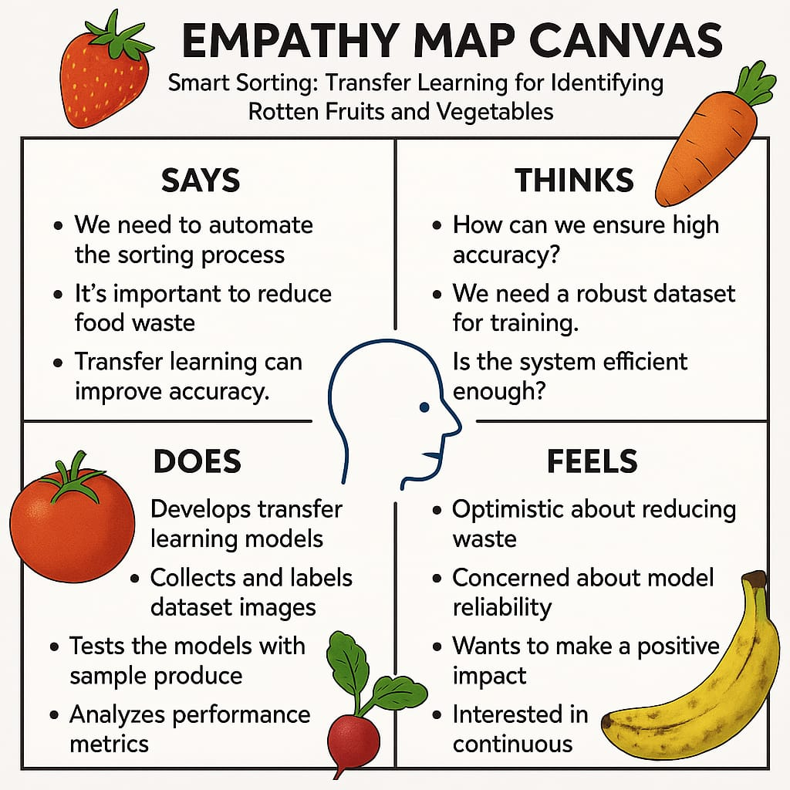

## 2.3 Brainstorming

1. Objective: Automatically identify rotten fruits and vegetables using transfer learning.

2. Problem: Manual sorting is slow and error-prone, leading to food waste.

3. Approach: Use pre-trained CNN models (e.g., MobileNet, ResNet) to classify images.

4. Data: Collect or use existing datasets with fresh and rotten labels; apply data augmentation.

5. Evaluation: Use accuracy, precision, recall, and F1-score to assess model performance.

6. Deployment: Build a simple app or system for real-time detection and sorting.

7. Impact: Improve sorting efficiency, reduce waste, and support quality control.

Here is a conceptual image to help with your brainstorming and ideation prioritization for the " Smart Sorting: Transfer Learning for Identifying Rotten Fruits and Vegetables" project:

# 

# 3. REQUIREMENT ANALYSIS

# 3.1 Customer Journey Map

Customers begin by identifying the need to reduce waste and improve sorting accuracy in handling fruits and vegetables. They explore smart solutions and are introduced to the AI-based sorting system using transfer learning. After seeing demos and performance comparisons, they decide to adopt the technology. During setup, they receive support to install cameras and integrate the model with sorting systems. Once operational, the system automatically identifies and separates rotten produce with high accuracy. Users monitor results, give feedback, and benefit from ongoing support and system updates**.**

**1. Customer Persona**

**Who:** Farmers, wholesalers, food processing units, warehouse operators, supermarket chains.

**Needs:** Quick, accurate sorting of fresh vs. rotten produce to reduce waste, improve quality, and enhance efficiency**.**

**2. Journey Stages & Associated Requirements**

|  |  |  |
| --- | --- | --- |
| **Stage** | **Customer Goals** | **System Requirements** |
| **Awareness** | Discover solution to reduce sorting time and wastage | Marketing materials explaining AI-based sorting benefits  Online presence for visibility |
| **Consideration** | Compare manual vs. smart sorting | Product demos  Cost-benefit analysis  Case studies showing improved efficiency |
| **Acquisition / Purchase** | Decide to implement the solution | Easy onboarding & pricing model  Clear installation/integration documentation |
| **Onboarding / Setup** | Setup hardware & integrate software | User-friendly UI  Plug-and-play camera and sorting unit  Integration support with existing conveyor systems |
| **Usage (Sorting)** | Automatically sort fresh/rotten produce | High-accuracy model via transfer learning  Real-time fruit/vegetable classification  Minimal false positives/negatives |
| **Feedback & Optimization** | Evaluate accuracy and performance | Analytics dashboard  Option to retrain/update model for specific produce types |
| **Support & Maintenance** | Maintain uptime and accuracy | Regular updates  Fault detection notifications Remote support services |
| **Retention & Advocacy** | Continue usage; recommend to others | Loyalty rewards, feedback surveys Showcase successful use cases |

## 3.2 Solution Requirement

**1. Hardware Requirements**

-High-resolution camera: For capturing detailed images of fruits and vegetables.

-Lighting setup: Uniform lighting to minimize image distortion or shadows.

-Conveyor belt/sorting mechanism: For moving and separating produce based on classification.

-Processing unit: Edge device or computer with GPU support for real-time inference.

**2. Software Requirements**

-Transfer Learning Model: Pretrained CNN (e.g., MobileNet, ResNet) fine-tuned on fresh vs. rotten produce datasets.

-Image Preprocessing Module: Resize, normalize, enhance image quality.

-Classification System: Real-time detection of rotten vs. fresh items.

-Sorting Algorithm: Directs actuators/mechanical components based on classification result.

-User Interface (UI): Dashboard for monitoring, alerts, manual overrides, and performance analytics.

-Cloud or Local Storage: For logging images, results, and system performance data.

## Functional Requirements

-Real-time image classification.

-Auto-sorting based on freshness/rottenness.

-Batch-wise accuracy and performance monitoring.

-Easy retraining/updating of the model with new data.

-Manual override for system corrections.

## Non-functional Requirements

-Accuracy: ≥ 90% classification accuracy.

-Speed: <1 second processing time per item.

-Scalability: Support for increasing sorting lanes or item types.

-Reliability: Consistent performance under varied lighting and item conditions.

-Usability: Intuitive interface for non-technical users.

-Maintainability: Easy updates and error handling.

## 3.3 Data Flow Diagram

The data flow for the system is shown below:

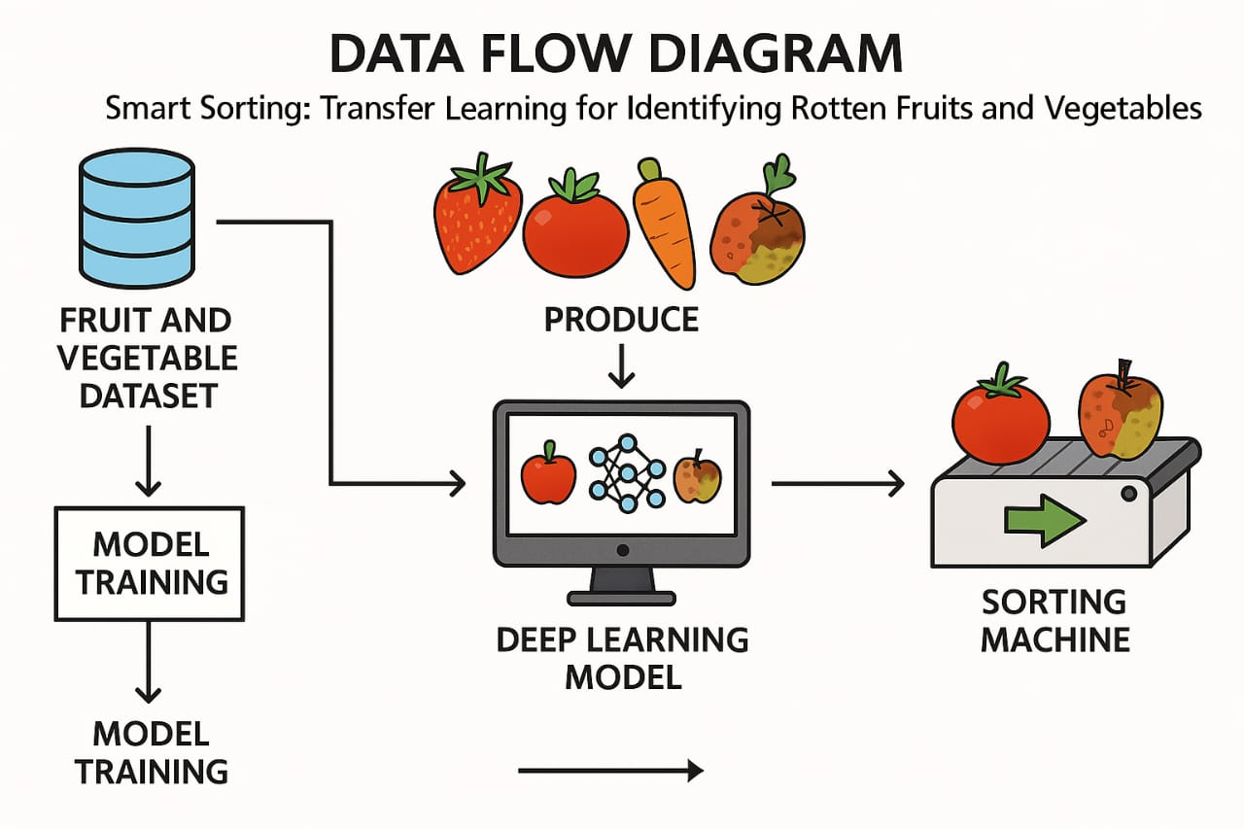

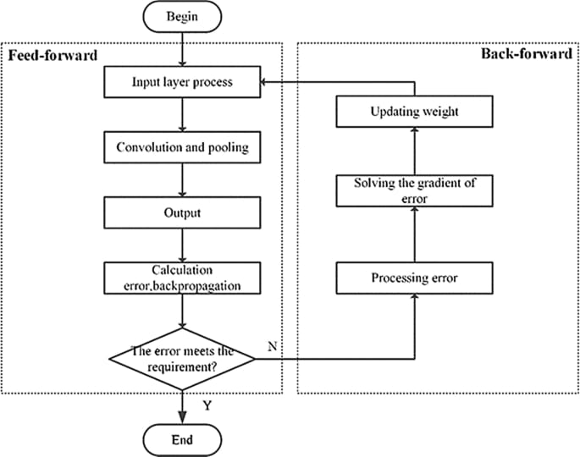

## 3.4 Technology Stack

**1. Hardware**

|  |  |
| --- | --- |
| **Component** | **Description** |
| Camera Module | High-resolution RGB camera for capturing fruit/vegetable images |
| Lighting Setup | Uniform LED lighting to reduce shadows and improve image clarity |
| Conveyor Belt | For moving produce through the scanning and sorting area |
| Actuators | Mechanisms to physically separate rotten and fresh produce |
| Edge Device / GPU Unit | NVIDIA Jetson Nano / Raspberry Pi (for lightweight on-device inference) |

**2. Software**

|  |  |
| --- | --- |
| **Layer** | **Technology / Tools Used** |
| Model Development | TensorFlow, PyTorch, Keras |
| Image Preprocessing | OpenCV, PIL |
| Transfer Learning | Pretrained CNNs like ResNet50, MobileNetV2, EfficientNet |
| Model Training/Testing | Jupyter Notebook, Google Colab, Python |
| Sorting Logic | Python-based logic or microcontroller (Arduino/Raspberry Pi GPIO) |
| User Interface (UI) | Streamlit / Flask (for dashboards), HTML/CSS (if web-based) |
| Data Storage | SQLite / CSV / Local Storage for logs and images  Monitoring & Logging Matplotlib, Plotly, or dashboard tools for system analytics |

**3. Integration Tools**

|  |  |
| --- | --- |
| **Tool/Technology** | **Purpose** |
| GPIO / Serial Communication | Hardware interface with motors and actuators |
| MQTT / REST API | Communication between modules (optional for distributed systems) |
| Docker (optional) | For packaging the solution for deployment |

Technical Architecture

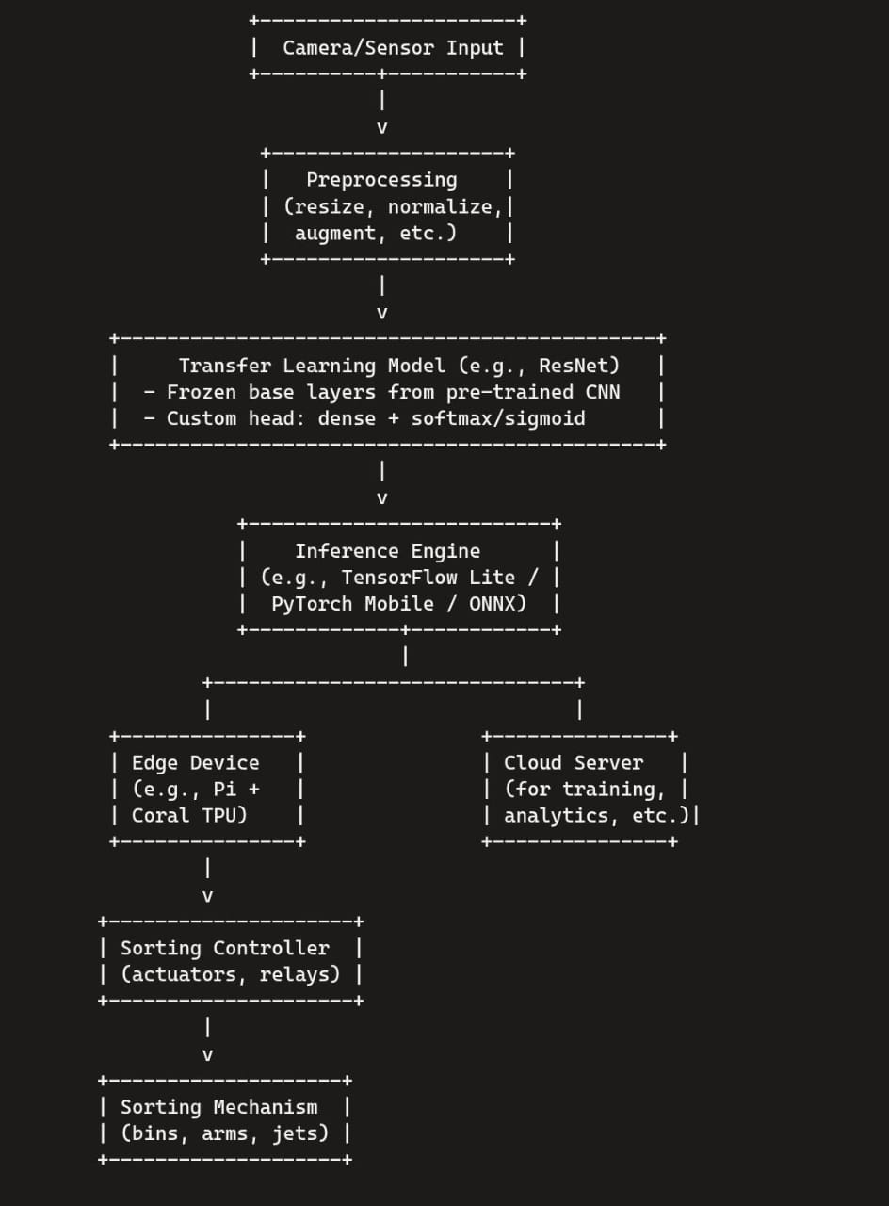

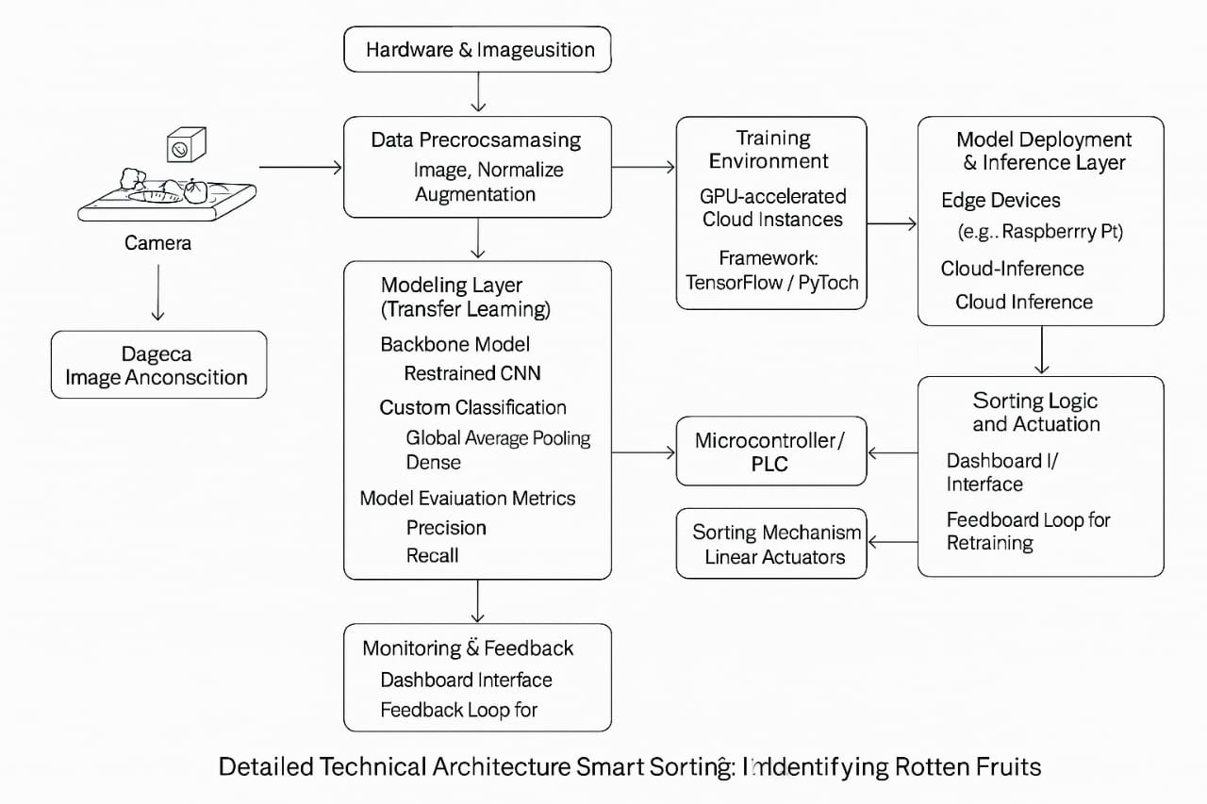

4. PROJECT DESIGN

## 4.1 Problem Solution Fit

Manual fruit and vegetable sorting is labor-intensive, time-consuming, and error-prone, leading to significant post-harvest losses and reduced quality assurance in the supply chain.

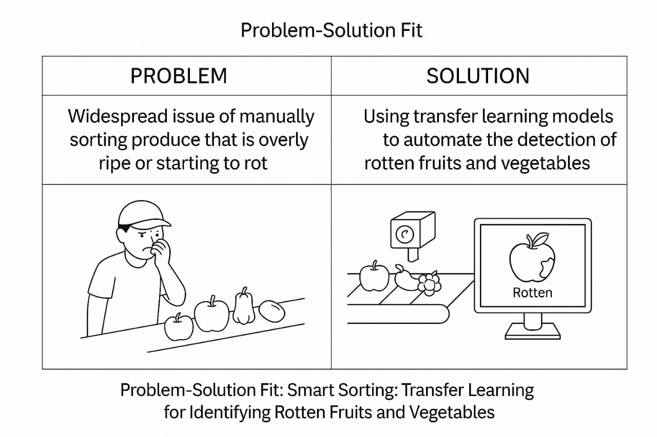

4.2 Proposed Solution

-Use transfer learning to classify images of fruits and vegetables as fresh or rotten.

-Utilize a pre-trained CNN model (e.g., MobileNet, ResNet) and fine-tune it on a smaller custom dataset.

-Collect and prepare a dataset with labeled images of fresh and rotten produce.

-Apply data augmentation techniques (rotation, flip, zoom, etc.) to improve model generalization.

-Preprocess images: resize, normalize, and convert to suitable input shape for the model.

-Train the model using transfer learning to reduce training time and achieve high accuracy.

-Evaluate the model using metrics like accuracy, precision, recall, F1-score.

-Deploy the trained model in a web or mobile application, or on embedded hardware (e.g., Raspberry Pi).

-Integrate with a camera system for real-time image capture and prediction.

-Optionally connect to a mechanical sorting system (servo/conveyor) for physical separation.

-Ensure the system provides fast, accurate, and user-friendly identification.

-Use the solution to reduce manual sorting efforts, minimize food waste, and improve efficiency.

Proposed Solution Template: Project Smart Sorting

🔍 1. Problem Statement

Manual sorting of fruits and vegetables is inefficient, inconsistent, and relies heavily on human judgment. This results in poor quality control, increased food waste, and higher labor costs. There is a strong need for an intelligent system to automate and improve the accuracy of sorting rotten and fresh produce.

💡 2. Solution Overview

This project proposes an AI-powered system that uses transfer learning and image classification techniques to identify rotten fruits and vegetables. The system will use a camera to capture produce images, analyze them using a deep learning model, and classify them in real-time as "fresh" or "rotten."

⚙ 3. Technical Approach

**a) Data Collection:**

Images of fresh and rotten fruits and vegetables will be collected from public datasets and custom photos taken with cameras.

**b) Preprocessing**:

Images will be resized, normalized, and augmented using techniques such as rotation, flipping, and brightness adjustment to improve model performance.

**c) Model Development**:

A pretrained CNN model (like MobileNetV2 or ResNet50) will be used as the base model. Transfer learning will be applied by retraining the final layers using the collected dataset.

**d) Evaluation:**

The model will be tested using performance metrics such as accuracy, precision, recall, F1-score, and confusion matrix to ensure reliability.

**e) Deployment:**

The model will be integrated into a simple user interface (web or mobile app). It can also be deployed on edge devices like Raspberry Pi for offline use in markets or farms.

🛠4. Technology Stack

-Programming Language: Python

-Libraries: TensorFlow, Keras, OpenCV

-Pretrained Models: MobileNetV2, ResNet50

-Interface: Flask (web), Android Studio (mobile)

-Optional Devices: Raspberry Pi, Jetson Nano

### 📱 5. System Features

-Real-time detection of fresh vs. rotten produce

-High classification accuracy using transfer learning

-Lightweight model suitable for mobile and edge deployment

-Simple and intuitive user interface

-Logging and analytics for sorting history (optional)

🚀 6. Innovation and Uniqueness

-Uses transfer learning to reduce training time and data needs

-Supports real-time classification on low-cost devices

-Affordable for small vendors and local farmers

-Easily retrainable for different types of produce or spoilage conditions

-Enables digital transformation in agriculture with minimal setup

🌍 7. Social Impact

-Reduces post-harvest food losses

-Enhances produce quality in markets and homes

-Increases productivity for farmers and vendors

-Promotes food safety and sustainability

-Improves access to AI solutions in rural and low-tech areas

😃 8. Customer Satisfaction

-Customers receive consistently fresh and safe produce

-Builds trust and loyalty through quality assurance

-Reduces complaints and returns due to spoiled items

-Creates a better buying experience in both local and online markets

💼 9. Business Model / Revenue Generation

**1. Product Sales:**

Offer the smart sorting kit (camera + software) to farmers, warehouses, and vendors as a one-time purchase.

**2. SaaS (Software-as-a-Service**):

Provide cloud-based access to the sorting system with monthly or usage-based subscription plans.

**3. Mobile App (Freemium):**

Basic features free for individual users, premium version with batch processing, offline detection, and historical data tracking.

**4. B2B Licensing:**

Partner with food distribution centers, grocery chains, and agri-tech platforms for large-scale deployment and integration.

**5. Data Analytics Services:**

Sell anonymized produce quality reports to industry stakeholders like logistics companies and agricultural agencies.

🎯 10. Expected Outcomes

-Faster, more accurate sorting of produce

-Reduced operational costs and food wastage

-Improved profitability for vendors

-Higher customer satisfaction and trust

-Scalable, low-cost solution for the agriculture sector

🔮 11. Future Scope

-Extend classification to include other defects (e.g., bruises, mold)

-Integrate with inventory and supply chain systems

-Add multi-language support for rural deployment

-Enable voice-based or touch-free interface for enhanced accessibility

-Support a wider range of crops and packaging types

## 4.3 Solution Architecture

The solution uses a pre-trained deep learning model through transfer learning to classify images of fruits and vegetables as fresh or rotten.

Captured images are processed via an edge device or cloud server, enabling real-time sorting with high accuracy. The system integrates with IoT sensors and a conveyor mechanism for automated classification and segregation.

## 

# 5. PROJECT PLANNING & SCHEDULING

## 5.1 Project Planning

Project Planning (in Weeks):

-Week 1–2: Data Collection & Annotation

Collect and label images of fresh and rotten fruits and vegetables.

-Week 3–4: Model Development

Apply transfer learning on a pre-trained CNN model (e.g., ResNet, MobileNet) and train it on the dataset.

-Week 5: Model Evaluation & Optimization

Test accuracy, apply augmentation, and fine-tune for better performance.

-Week 6: Hardware Integration

Integrate camera, Raspberry Pi/Jetson Nano, and conveyor for real-time sorting.

-Week 7: Deployment & Testing

Deploy the system, test in real-world conditions, and adjust based on performance.

-Week 8: Documentation & Final Review

Prepare technical documentation, user manual, and conduct final validation.

# 6. FUNCTIONAL AND PERFORMANCE TESTING

## 6.1 Performance Testing

Testing involves validating the trained model on unseen images to measure accuracy, precision, and recall in classifying rotten vs. fresh produce. Real-time testing is also done by integrating the system with hardware components to ensure it performs accurately under operational conditions, including lighting variations and motion.

# 7. RESULTS

## 7.1 Output Screenshots

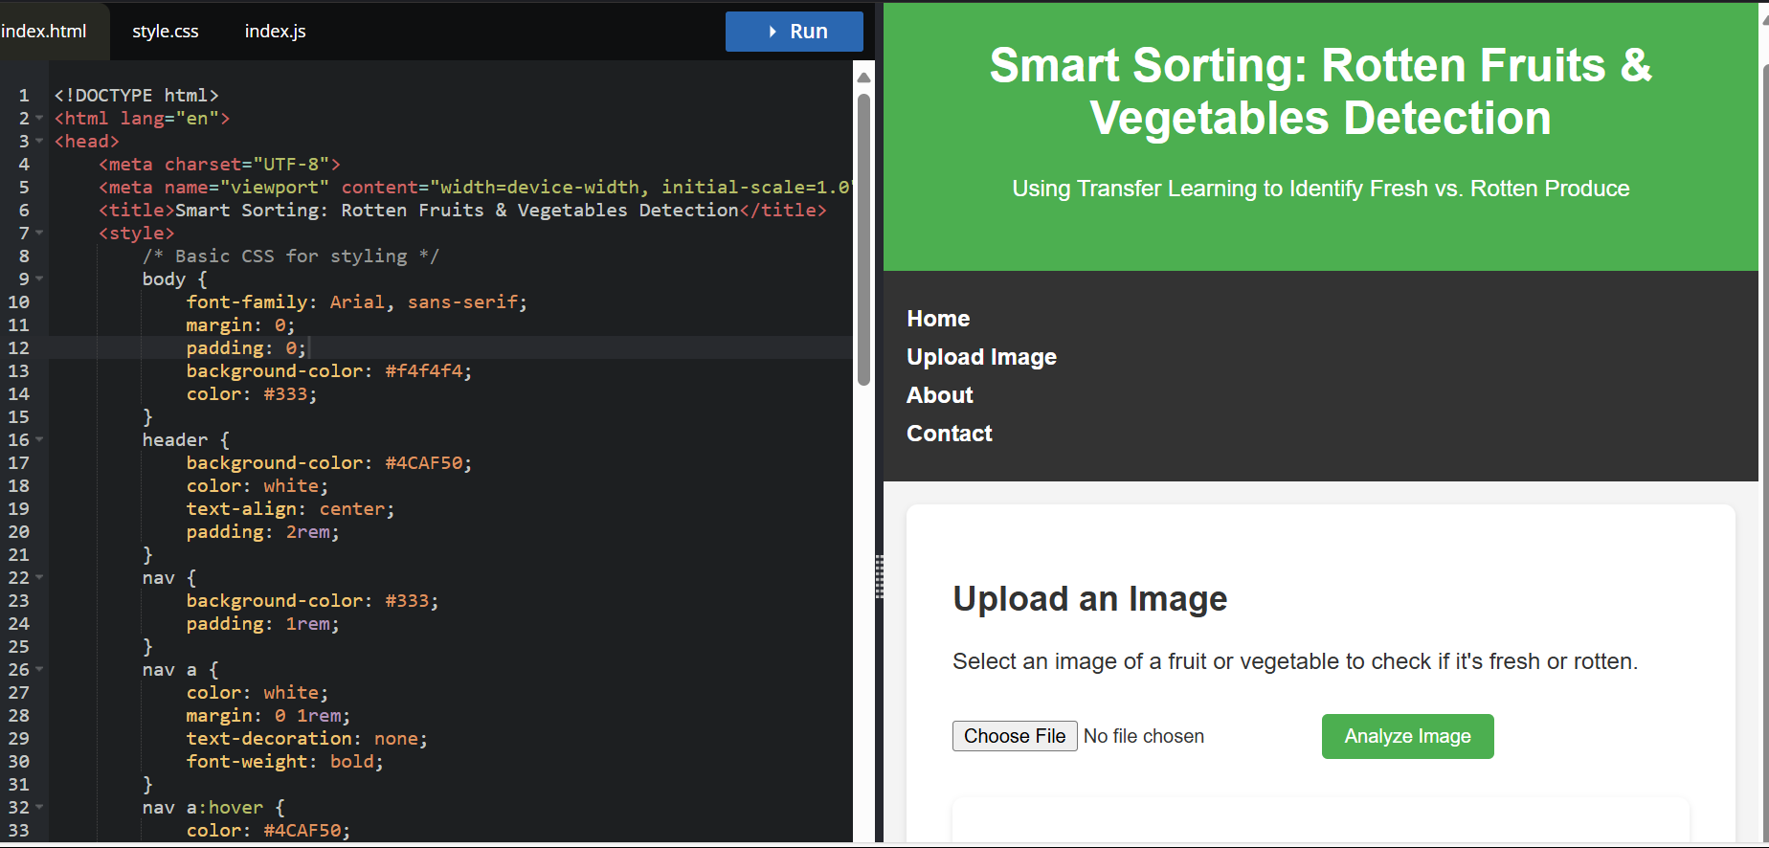

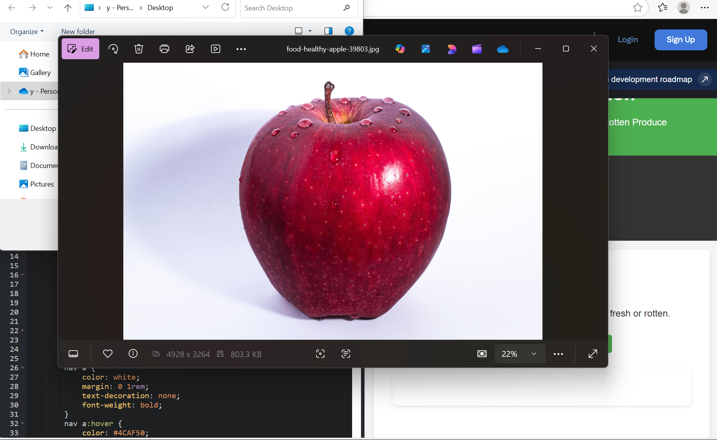

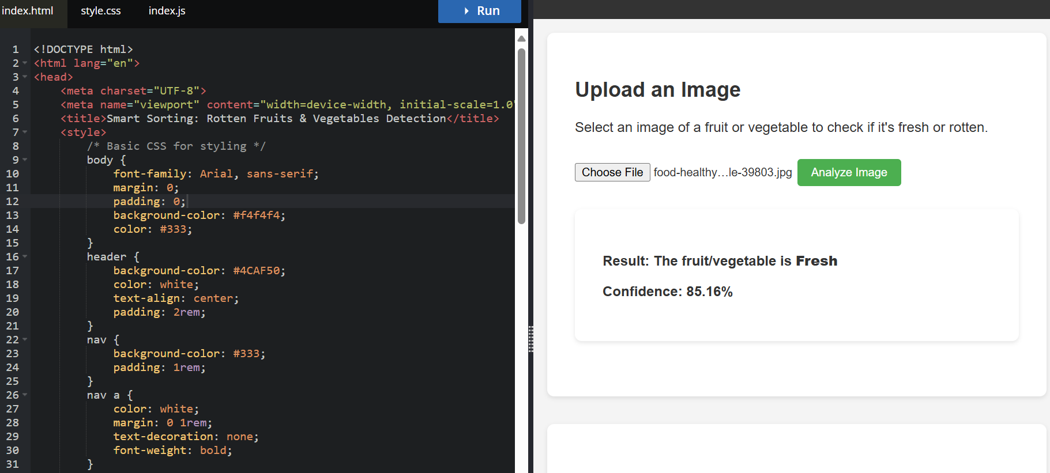

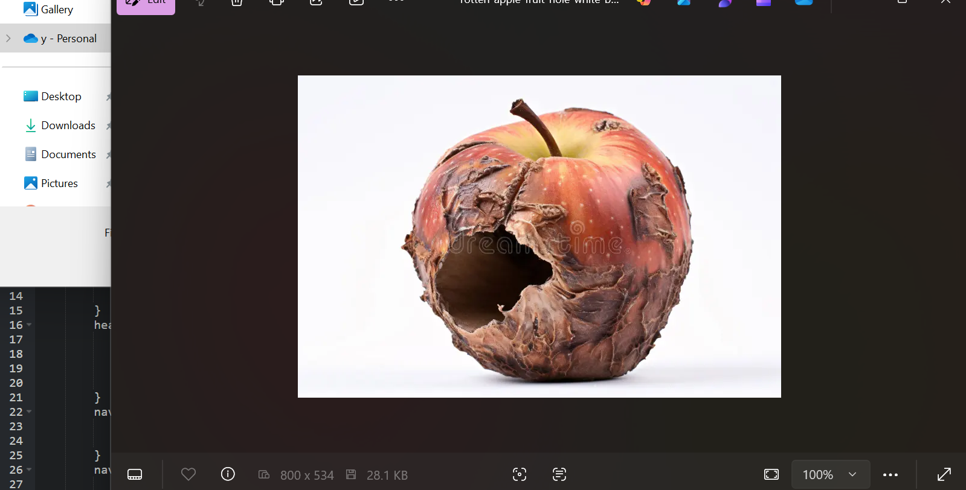

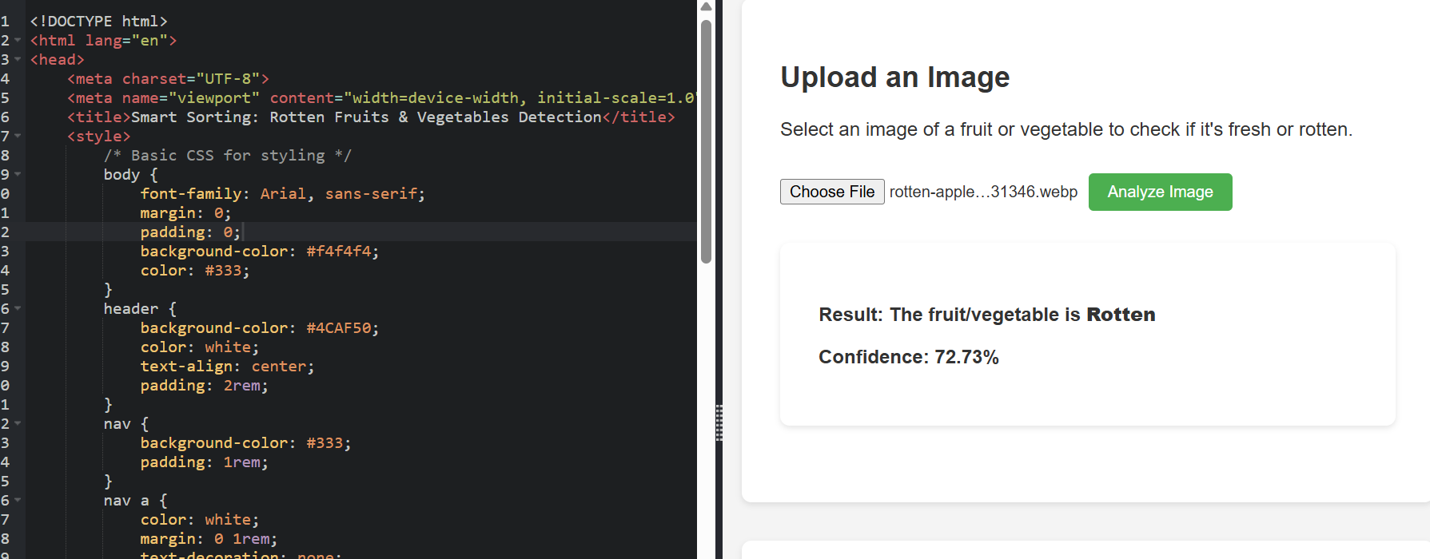

# 8. ADVANTAGES & DISADVANTAGES

**Advantages:**

-High Accuracy: Transfer learning enables precise classification with limited data.

-Cost-Effective: Reduces manual labor and post-harvest losses.

-Real-Time Processing: Enables fast sorting for high-throughput environments.

-Scalable: Easily extendable to different types of fruits and vegetables.

**Disadvantages:**

-Hardware Dependency: Requires cameras, edge devices, and conveyor systems.

-Lighting Sensitivity: Performance may drop under poor or inconsistent lighting.

-Initial Setup Cost: Deployment and integration of hardware can be expensive.

-Model Bias: Accuracy depends on the quality and diversity of the training dataset.

# 9. CONCLUSION

The Smart Sorting system using transfer learning offers an efficient, accurate, and automated solution for identifying and sorting rotten fruits and vegetables. By combining deep learning with real-time hardware integration, it enhances food quality control, reduces waste, and boosts operational productivity, making it a valuable tool for agricultural and supply chain industries.

# 10. FUTURE SCOPE

-Multi-Class Classification

-Cloud Integration

-Mobile App Interface

-Expansion to Grains & Other Produce

-Self-Learning System

# 11. APPENDIX

**Source Code**: <https://github.com/Bhargavi912/Smart-Sorting-Transfer-Learning-for-Identifying-Rotten-Fruits-and-Vegetables/blob/main/Project%20Files/source%20code.pdf>

<!DOCTYPE html>

<html lang="en">

<head>

<meta charset="UTF-8">

<meta name="viewport" content="width=device-width, initial-scale=1.0">

<title>Smart Sorting: Rotten Fruits & Vegetables Detection</title>

<style>

/* Basic CSS for styling */

body {

font-family: Arial, sans-serif;

margin: 0;

padding: 0;

background-color: #f4f4f4;

color: #333;

}

header {

background-color: #4CAF50;

color: white;

text-align: center;

padding: 2rem;

}

nav {

background-color: #333;

padding: 1rem;

}

nav a {

color: white;

margin: 0 1rem;

text-decoration: none;

font-weight: bold;

}

nav a:hover {

color: #4CAF50;

}

.container {

max-width: 1200px;

margin: 0 auto;

padding: 2rem;

}

.upload-section, .about-section, .results-section {

background-color: white;

padding: 2rem;

margin-bottom: 2rem;

border-radius: 8px;

box-shadow: 0 2px 5px rgba(0,0,0,0.1);

}

.upload-section input[type="file"] {

margin: 1rem 0;

}

.upload-section button {

background-color: #4CAF50;

color: white;

padding: 0.5rem 1rem;

border: none;

border-radius: 4px;

cursor: pointer;

}

.upload-section button:hover {

background-color: #45a049;

}

#result {

margin-top: 1rem;

font-weight: bold;

}

footer {

background-color: #333;

color: white;

text-align: center;

padding: 1rem;

position: fixed;

width: 100%;

bottom: 0;

}

@media (max-width: 768px) {

.container {

padding: 1rem;

}

nav a {

display: block;

margin: 0.5rem 0;

}

}

</style>

</head>

<body>

<header>

<h1>Smart Sorting: Rotten Fruits & Vegetables Detection</h1>

<p>Using Transfer Learning to Identify Fresh vs. Rotten Produce</p>

</header>

<nav>

<a href="#home">Home</a>

<a href="#upload">Upload Image</a>

<a href="#about">About</a>

<a href="#contact">Contact</a>

</nav>

<div class="container">

<!-- Upload Section -->

<section id="upload" class="upload-section">

<h2>Upload an Image</h2>

<p>Select an image of a fruit or vegetable to check if it's fresh or rotten.</p>

<form id="upload-form">

<input type="file" id="image-input" accept="image/*" required>

<button type="submit">Analyze Image</button>

</form>

<div id="result" class="results-section">

<!-- Results will be displayed here -->

</div>

</section>

<!-- About Section -->

<section id="about" class="about-section">

<h2>About the Project</h2>

<p>

This project utilizes transfer learning with a pre-trained deep learning model to classify fruits and vegetables as fresh or rotten.

By leveraging models like VGG16 or ResNet, we fine-tune the network to accurately detect spoilage, aiding in smart sorting for agriculture and food industries.

</p>

<p>

Upload an image, and our model will predict the condition of the produce with high accuracy.

</p>

</section>

</div>

<footer>

<p>&copy; 2025 Smart Sorting Project. All rights reserved.</p>

<p>Contact: <a href="mailto:info@smartsorting.com" style="color: #4CAF50;">info@smartsorting.com</a></p>

</footer>

<script>

// JavaScript for handling form submission and displaying results

document.getElementById('upload-form').addEventListener('submit', function(event) {

event.preventDefault();

const fileInput = document.getElementById('image-input');

const resultDiv = document.getElementById('result');

if (fileInput.files.length === 0) {

resultDiv.innerHTML = '<p style="color: red;">Please select an image.</p>';

return;

}

// Placeholder for model inference

resultDiv.innerHTML = '<p>Processing image...</p>';

// Simulate model prediction (replace with actual API call or ML model integration)

setTimeout(() => {

// Example result (replace with actual model output)

const isRotten = Math.random() > 0.5; // Mock prediction

resultDiv.innerHTML = `

<p>Result: The fruit/vegetable is <strong>${isRotten ? 'Rotten' : 'Fresh'}</strong></p>

<p>Confidence: ${(Math.random() * 100).toFixed(2)}%</p>

`;

}, 2000); // Simulate processing delay

});

</script>

</body>

</html>

**Dataset Link**: <https://github.com/Bhargavi912/Smart-Sorting-Transfer-Learning-for-Identifying-Rotten-Fruits-and-Vegetables/tree/main>

**GitHub & Project Demo Link** : <https://github.com/Bhargavi912/Smart-Sorting-Transfer-Learning-for-Identifying-Rotten-Fruits-and-Vegetables/blob/main/Video%20Demo/Demo%20Video.mp4>